Abstract

Space-time Tag Planning
netention.org
A system for suggesting when and where individuals may be involved in similar activities that they have specified that they would like to do.

Introduction
Calendar and scheduling software applications are commonly used to plan individual and group activities. This system allows arbitrary tags to be associated with time and space locations to coordinate activity in an arbitrary large population, representing intention vectors. Such tags are generally selected from Wikipedia, serving as a foundation ontology, and can encompass any subject whether it is an activity, physical object, or abstract object.

Populating the vector space with novel opportunities for its participants requires more than one individual user.

Collecting Intentions and Displaying Opportunities
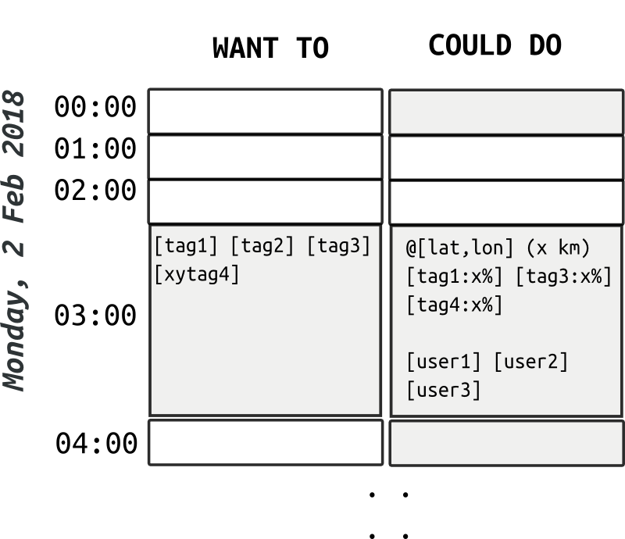
Many possible graphical-user-interfaces can be designed to elicit “intention vectors” from a user. The simplest resemble an hour-based calendar starting from the present moment and extending an arbitrary amount of time into the future. The calendar can be arbitrarily subdivided into smaller time-units – the hour is an arbitrary amount of time that seems, to the author, reasonable for allocating intentions.
Each moment can be described in certain aspects:

- Want To: what one intends to do or would like to happen, specified as a list of tags
- Could Do: recommendations for possible activities (opportunities), specified in terms of:

  - where (latitude/longitude coordinates)
  - when
  - with whom may be involved
  - what “should” occur as a semantic vector of the tags with the magnitude of its components, in the range of 0..1.0, indicating the relative strength of its presence in this vector

Clicking a cell in the 'Want to' column allows one to select the tags associated with that time slot, perhaps through a pop-up dialog window.

In a multi-user system, anyone editing their 'Want to' column would automatically trigger an updating of everyone's 'Could do' column since the clustering results, described in (3), need to be updated.

These updates can be throttled to an arbitrary finite time of maximum frequency. The soonest future time slots can be calculated at a higher priority than later ones allowing near-future plans to be more adaptively and fluidly scheduled.

Intention Vectors
The structure of the N-dimensional vector, when clustered, generates recommendations (“could do”) which consist of the following components:

- Time (ex: unixtime)
- Geographic Latitude
- Geographic Longitude
- tag0? [0: not present .. 1.0: present]
- tag1? [0: not present .. 1.0: present]
- …
- tagN? [0: not present .. 1.0: present]

Clustering
Various clustering methods may be applicable for this system. K-means clustering provides results in the form of centroids in the vector space which can be interpreted as possible meetings between the users who have planned their time with this system.

The distance function between points in the vector space can be biased to favor one set of dimensions or another. For example, to make space, time, or tags proportionally more or less relevant to each other.

Improving Semantic Matches with Wikipedia Categories
Many Wikipedia pages are tagged with the “Categories” that it involves. (Categories can also be part of other super-categories.) This forms a taxonomy that can be used to add extra tags to the intention vectors by including all a wikipage's parent categories to a finite amount of iterations. These can be gathered from a page's wikitext or from DBpedia's “skos:broader” property.

These additional “virtual” category tags may be assigned slightly differently strength values (within 0..1.0) than explicitly chosen tags.

Predicting an Individual's Future Behavior
Another column for each time slot can show a prediction for an individual's future tags at a given time-slot, according to one's historic entries. This can serve as a reminder system.

When an item is no longer desired to be remembered, one can be explicitly “forget” it via a button in the user-interface.

Space-less and Time-less Applications
When the space dimensions are not involved, the system identifies possible on-line meetings, or other situations where space is irrelevant.

When the time dimensions are not involved, the system identifies more-or-less permanent semantic “features” of a geographic region.

When neither space nor time dimensions are involved, the system identifies clusters of “interests” shared by users.

Conclusion
The ubiquitous application of this system could have a significant impact in a human society's daily functioning. It can help in all forms of gathering:

- education
- conferences
- business meetings
- medical
- social
- recreational
- amongst animals
- exotic forms of human interactions yet to be explored

